**Generated a dedicated domain administrator account:**

**New user prompt to change Password:**

**Other users password Log on Hours and expiration date:**

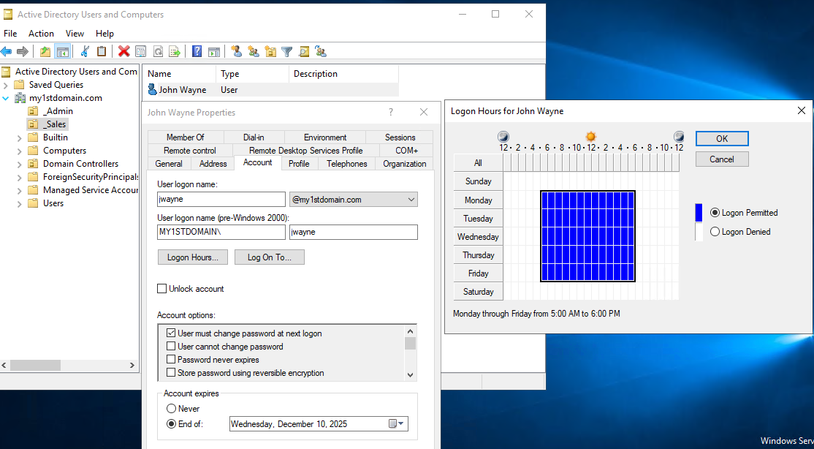

Configure routing so that clients on the private network can access the internet through the domain controller

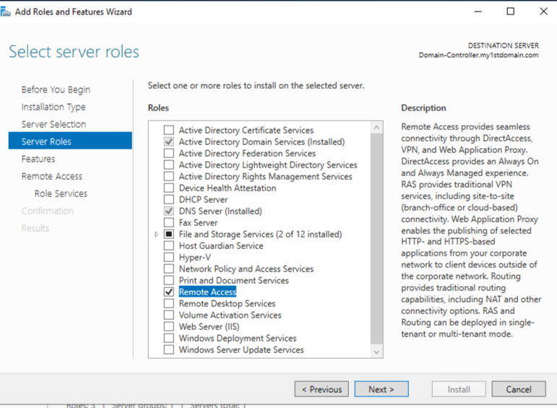

**Routing role services:**

**Set up DHCP on the DOMAIN CONTROLLER.**

**DHCP (1 Scope)**

Range: 172.16.0.0.100-200

Mask: 255.255.255.0

Gateway: 172.168.0.1

DNS: 172.16.0.1

**Address Range**:

**IPv4 Address assignment:**

